Reading
Autumn 1 |  | Autumn 2 | Spring 1 | Spring 2 | Summer 1 | Summer 2
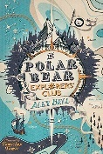  The Polar Bear Explorer’s Club by Alex Bell |  | 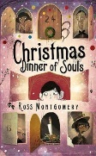  Christmas dinner of souls by Ross Montgomery | 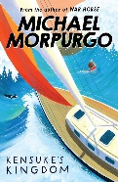  Kensuke’s Kingdom by Michael Morpurgo | 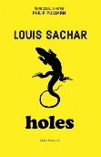  Holes by Louis Sacher | 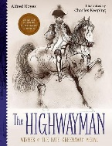  The Highwayman by Alfred Noyes | 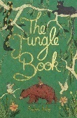  The Jungle Book by Rudyard Kipling
Biomes NF  Robert Ballad Biography |  | Circulatory Systen NF  A day in the life of a cardiologist (Interview) | David Attenborough NF  The Galapagos flying lizard Non Chronological Report | Animal NF  The Circus Life (Interview) (Past SATs) | Formal Letters  Famous Outlaws Non Chronological Report | Holiday Brochures  Guide Dogs Non Chronological Report
Writing
 | Autumn 1  Frozen Kingdom | Autumn 2  Star Gazers | Spring 1  Darwin’s Delights | Spring 2  Allotment | Summer 1 & 2  Hola Mexico!
Purpose for Writing  Text Type | To Entertain  Narrative: Descriptive writing (3 weeks)  To Inform  Non-Chronological Report: Biomes (x3 weeks) | To Explain  Explanation Text: Circulatory System (Science) x2wk  To Entertain  Narrative (Thriller) x3 wks  To Entertain  Monologue poetry: The Arrival | To Entertain  Diary Writing (in Role) x3wks  To Discuss  Balanced Argument Should animals be in captivity x2wks | To Inform  Non Chronological Report (Imaginary Beasts) x 2 wks  To Entertain  Narrative: Adventure  Disaster of the Peggy Sue x 3 wks | SPaG revision (2 week)  SATS week (1 week)  To Persuade  Formal (BBC) x2wk  To Entertain  Narrative Poetry x2wk | To Persuade  Mexico holiday brochure (linked to Geog) x2wks  To Entertain  Myth x2wks
Quality Text/ Extracts/  Stimulus | Northern Lights by Phillip Pullman  Chronicles of Narnia by C S Lewis.  Biomes Non Fiction Texts | Circulatory Systen Non Fiction Texts  Christmas dinner of souls by Ross Montgomery.  Clockwork by Phillip Pullman  An Arrival by Shaun Tan | Explorer by Katherine Rundell  Steve Backshall Texts  Captivity news article.  David Attenborough Little People Big Dreams | Fantastic Beasts by J K Rowling  Arthur Spiderwick’s Field Guided to Fantastical World Around You.  Kensuke’s Kingdom by Michael Morpurgo | The Highwayman by Alfred Noyes | The Curse of the Maya by John Pearce  Middleworld by J and P Voelkel  Rainplayer by David Wisniewski  You Wouldn’t Want to be a Mayan Soothsayer by Rupert Matthews
Oracy Projects | Class Assemblies | Christmas Carol Service (Poetry) | Debates | Assembly to Year 5 about the French Residential | Recording of the HWM | End of Year Performance
Performance Poetry |  | A Christmas Carol by Charles Dickens |  |  | The Highwayman by Alfred Noyes
National / World Events  *Purposeful writing & speaking and listening opportunities | National Poetry Day  Black History Month |  | National Storytelling Week | International Women’s Day  World Book Day  World Storytelling & Poetry Day | World Day for Cultural Diversity | World Environment Day
Story Time Texts | 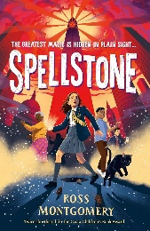  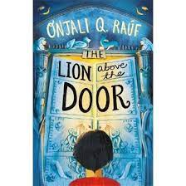  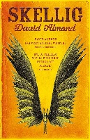  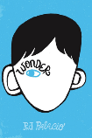  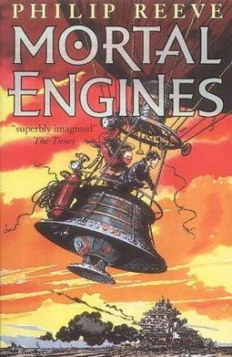
Poetry  Pie Corbett’s Year 6 Spine  Daily Poem | 