AUTUMN 1 | AUTUMN 2 |  | Spring 1 |  | Spring 2 |  | SUMMER 1 |  | Summer 2
All about me | Celebrations |  | Transport & Journeys |  | Farming |  | In the Garden |  | Fairy Tales & Nursery rhymes
-I enjoy sharing books with an adult.  -I have favourite books and seek them out, to share with an adult, with another child, or to look at alone.  -I enjoys songs and rhymes, tuning in and I am beginning to pay attention.  -With support, I can identify familiar objects and properties for practitioners when they are described: for example: ‘Katie’s coat’, ‘blue car’, ‘shiny apple’.  -With support, I enjoy drawing freely. | -I enjoy sharing books with an adult.  -I enjoys songs and rhymes, tuning in and to pay attention.  -I know some of the words in songs and rhymes.  -I can listen to simple stories and understand what is happening, with the help of the pictures.  -With support, I can identify familiar objects and properties for practitioners when they are described: for example: ‘Katie’s coat’, ‘blue car’, ‘shiny apple’.  -I can pay attention and respond to the pictures or the words when in small groups of 1-1.  I enjoy drawing freely |  | -I know some of the words in songs and rhymes.  -I am beginning to sing songs and say rhymes independently,  -I can listen to simple stories and understand what is happening, with the help of the pictures.  -I can identify familiar objects and properties for practitioners when they are described.  -I can pay attention and respond to the pictures or the words when it’s whole class story.  -I can ask questions about the book. Make comments and shares their own ideas during small group or 1-1 reading.  -Understand and act on longer sentences like ‘make teddy jump’ or ‘find your coat’.  -I enjoy drawing freely.  With support, I can add some marks to their drawings, which they give meaning to. |  | -I am beginning to sing songs and say rhymes independently,  -I can listen to simple stories and understand what is happening, with the help of the pictures.  -I can pay attention and respond to the pictures or the words when it’s whole class story.  -I can ask questions about the book. Make comments and shares their own ideas during small group or 1-1 reading.  -I can understand and act on longer sentences like ‘make teddy jump’ or ‘find your coat’.  I can understand simple questions about ‘who’, ‘what’ and ‘where’ (but generally not ‘why’) sometimes with prompts from my practitioner.  -I enjoy drawing freely.  -With support, I can add some marks to their drawings, which they give meaning to. For example: “That says mummy.” |  | -I can sing songs and say rhymes independently,  -I can pay attention and respond to the pictures or the words when it’s whole class story.  -I can ask questions about the book. Make comments and shares their own ideas during small group and who class stories.  -I can understand and act on longer sentences like ‘make teddy jump’ or ‘find your coat’.  -I can understand simple questions about ‘who’, ‘what’ and ‘where’ (but generally not ‘why’) sometimes with prompts from my practitioner.  -I can repeat words and phrases from familiar stories.  -With support, I can add some marks to their drawings, which they give meaning to. For example: “That says mummy.” |  | I can sing songs and say rhymes independently,  I know how to pay attention and respond to the pictures or the words when it’s whole class story.  I can ask questions about the book. Make comments and shares their own ideas during small group and who class stories.  I can understand and act on longer sentences like ‘make teddy jump’ or ‘find your coat’.  I can understand simple questions about ‘who’, ‘what’ and ‘where’ (but generally not ‘why’) sometimes with prompts from my practitioner.  I know words and phrases from familiar stories.  I can add some marks to their drawings, which they give meaning to. For example: “That says mummy.”  I can make marks on their picture to stand for their name.
Key Vocabulary:  Songs, nursery rhymes, books, crayons, felt tips, pencil. | Key Vocabulary:  Songs, nursery rhymes, books, stories, pictures, crayons, felt tips, pencil. |  | Key Vocabulary:  Songs, nursery rhymes, books, stories, pictures, crayons, felt tips, pencil. |  | Key Vocabulary:  Songs, nursery rhymes, books, stories, pictures, drawing |  | Key Vocabulary:  Songs, nursery rhymes, books, stories, pictures, drawing, writing. |  | Key Vocabulary:  Songs, nursery rhymes, books, stories, pictures, drawing, writing, name
Quality Texts
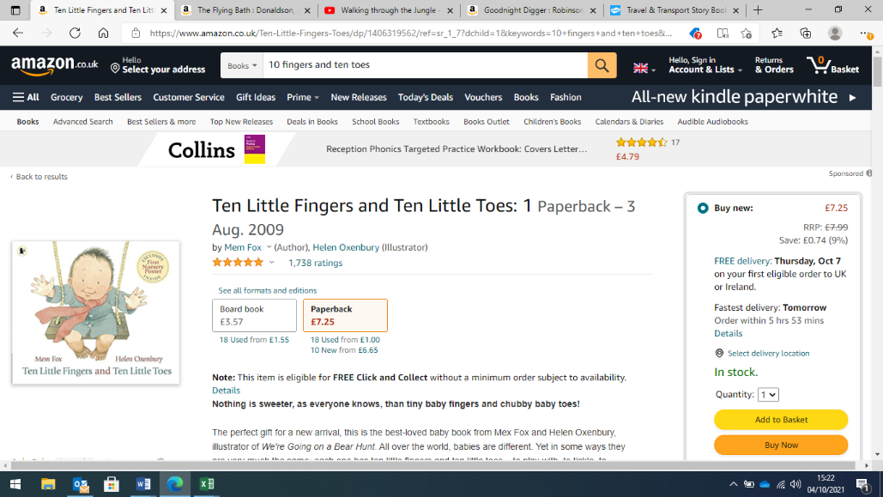  Mark making  (giving meaning) | 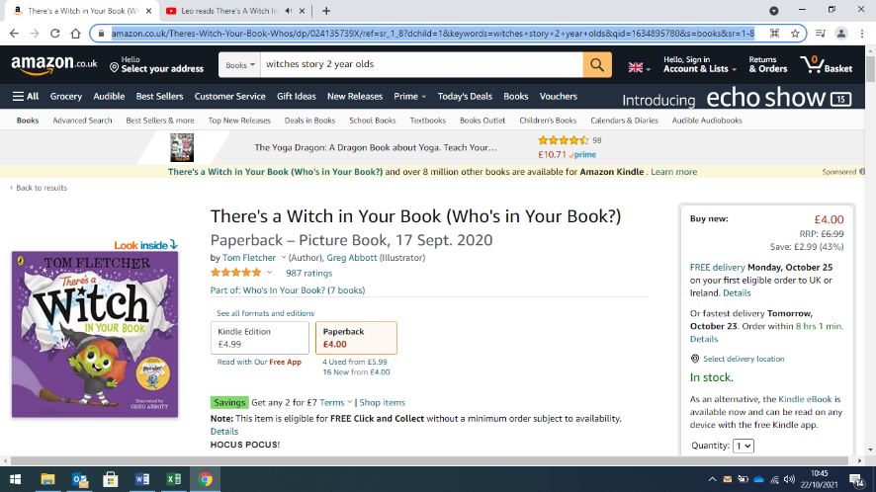  Making pumpkin faces |  | 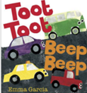  Car painting with wheels |  | 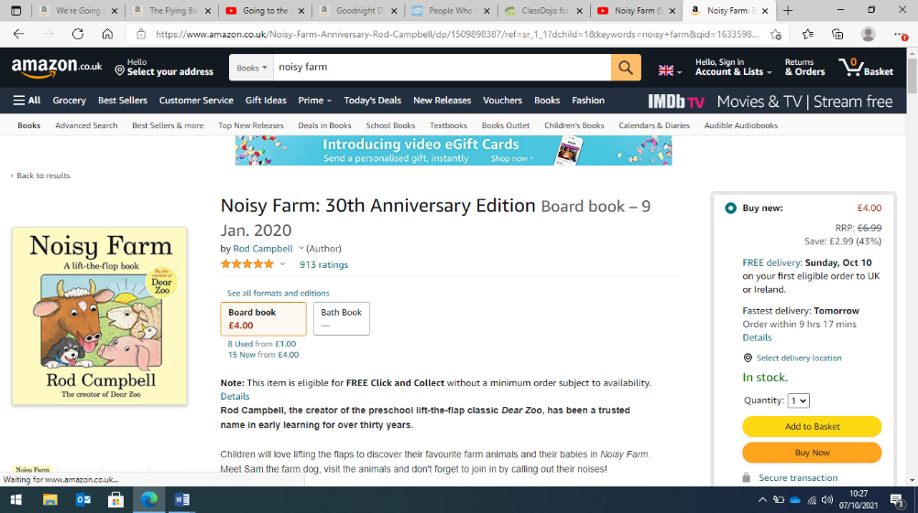  Animal feet printing |  | 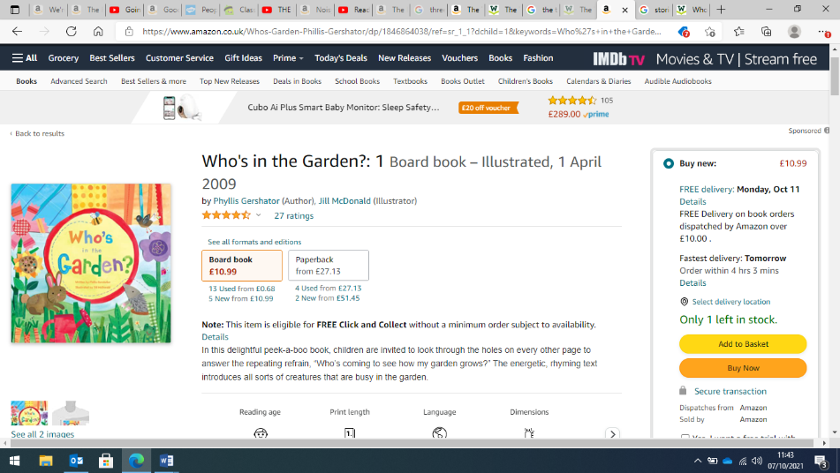  Flower painting |  | 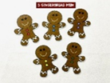  Using props to act out the story
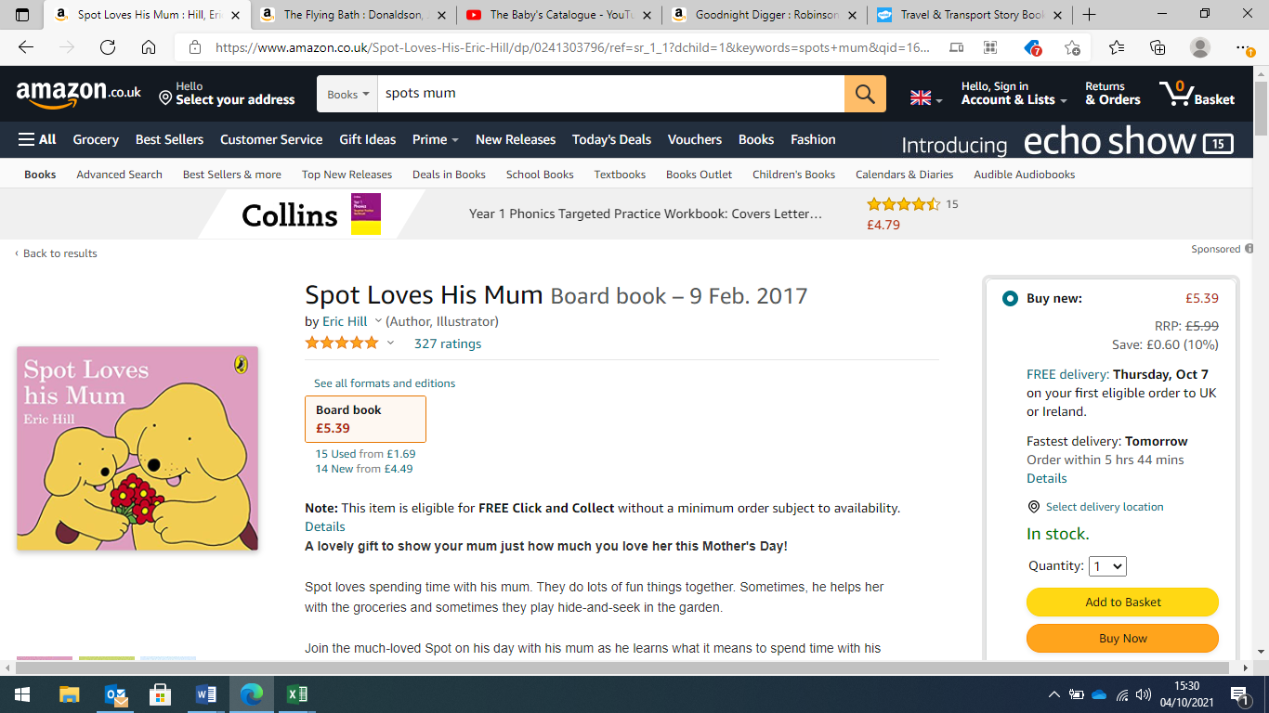  Creating self portraits | 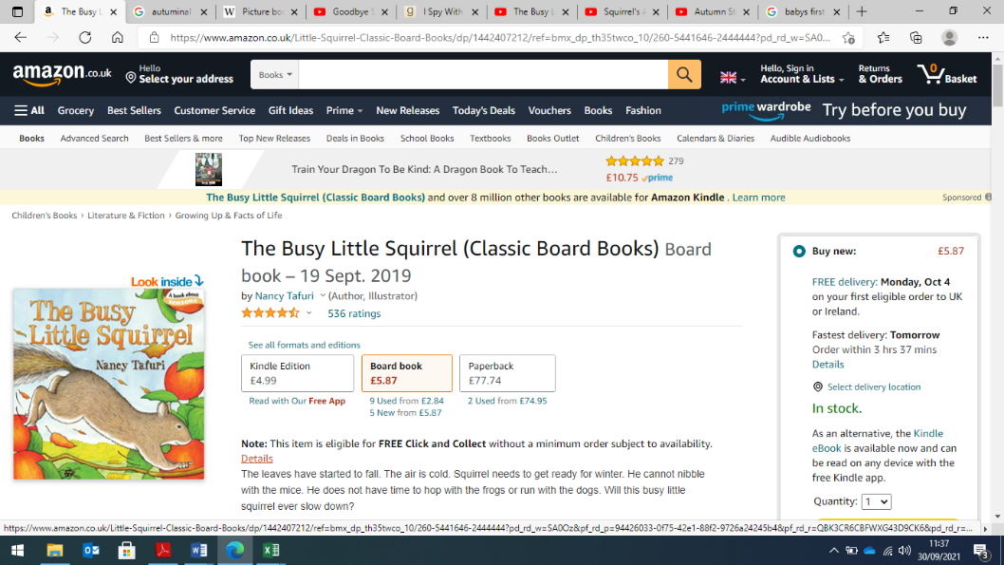  Leaf Printing |  | 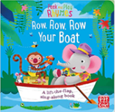  Printing boats |  | 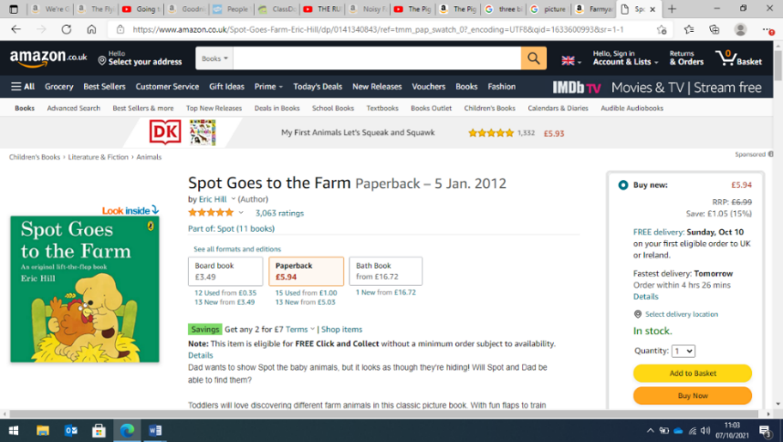  Fruit and vegetable  drawing |  | 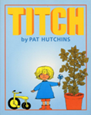  Flower printing |  | 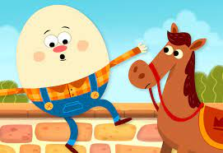  Paper plate faces
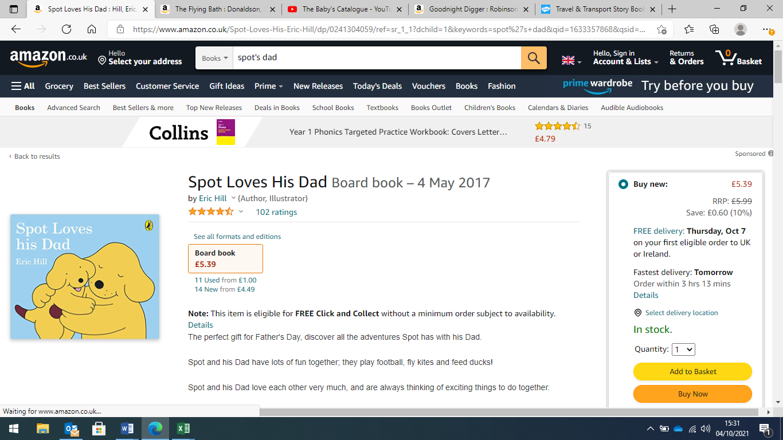  Drawing family pictures | 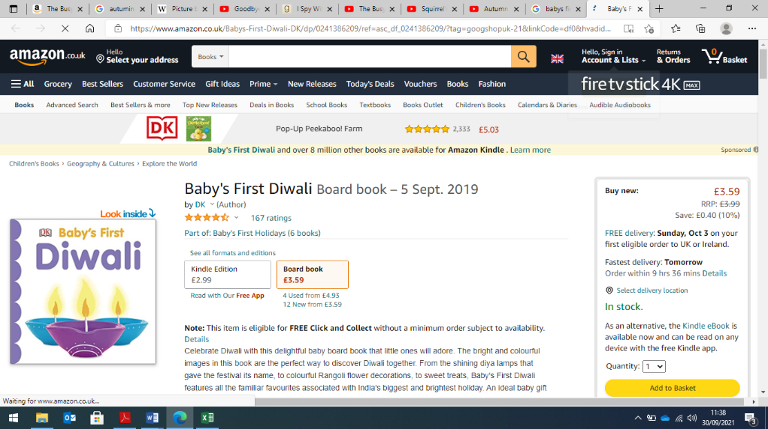  Making rangoli patterns |  | 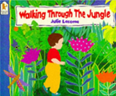  Animal masks |  | 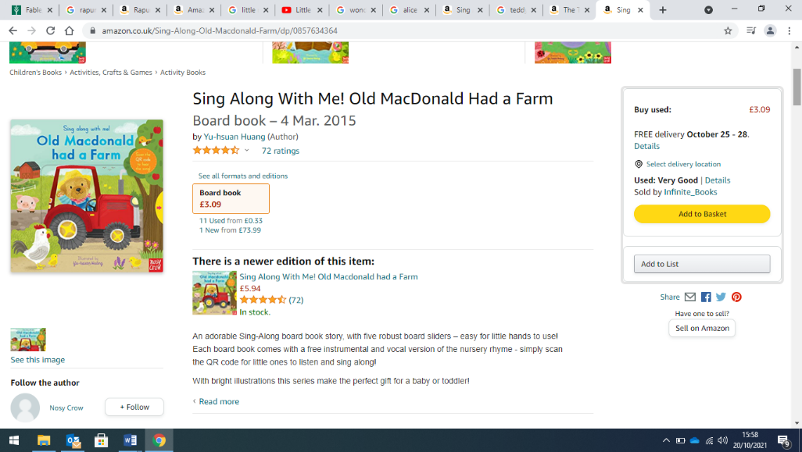  Creating animal masks |  | 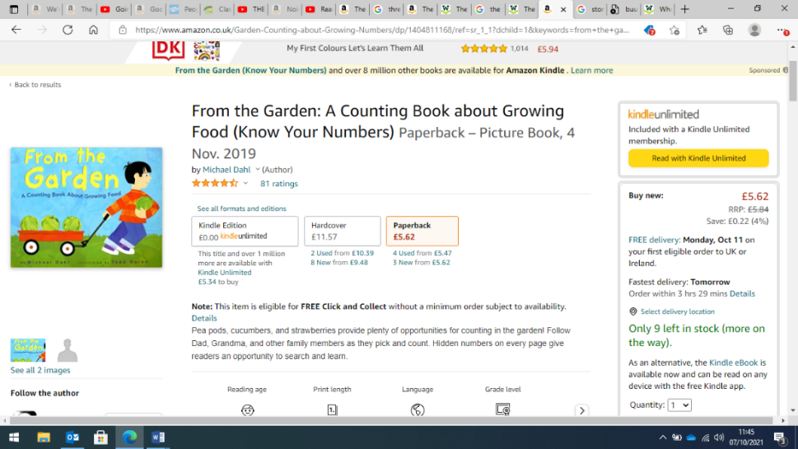  Vegetable printing |  | 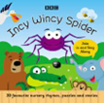  Creating spiders
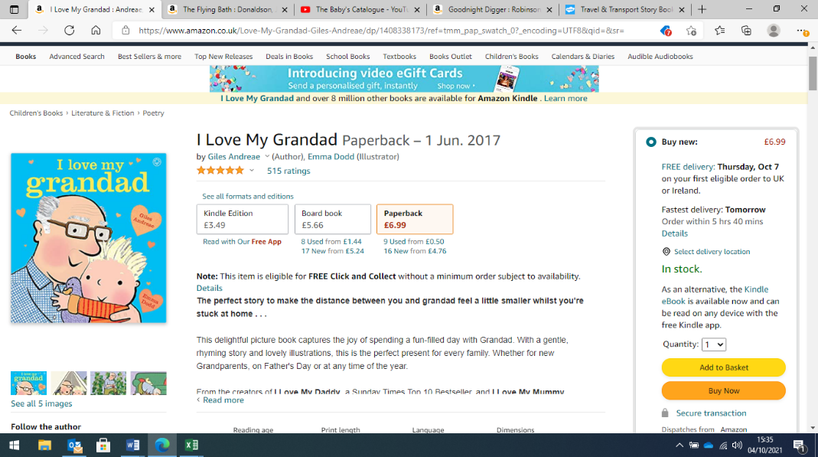  House printing | 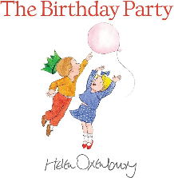  Making birthday cards |  | 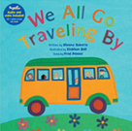  Mark making  passports |  | 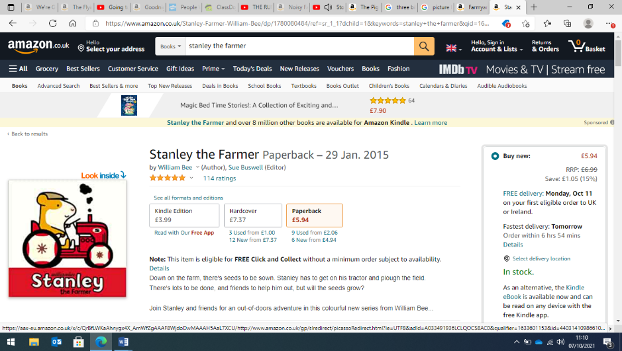  Painting  daffodils |  | 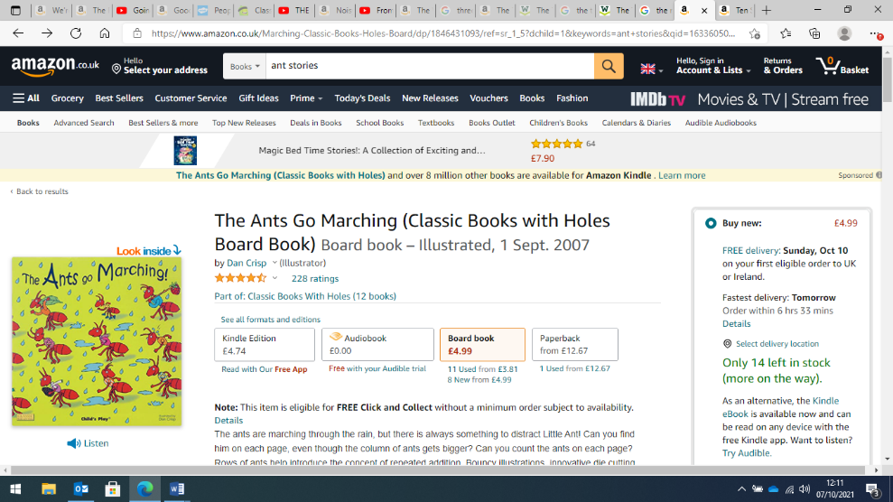  Pencil control ant maze |  | 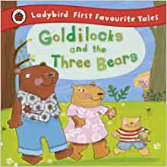  Creating bear masks
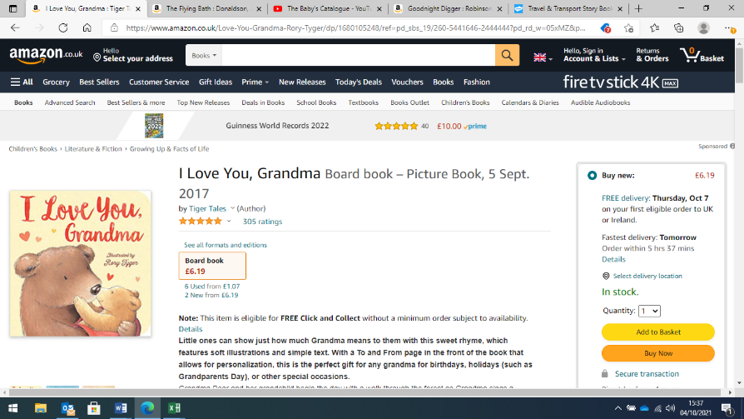  Mark marking in foam |  |  | 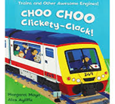  Painting vehicles |  | 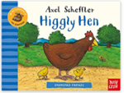  Roller ball painting |  | 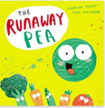  Roller ball painting |  | 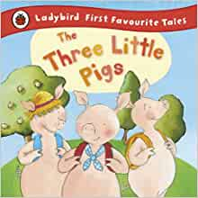  Making marks in gloop
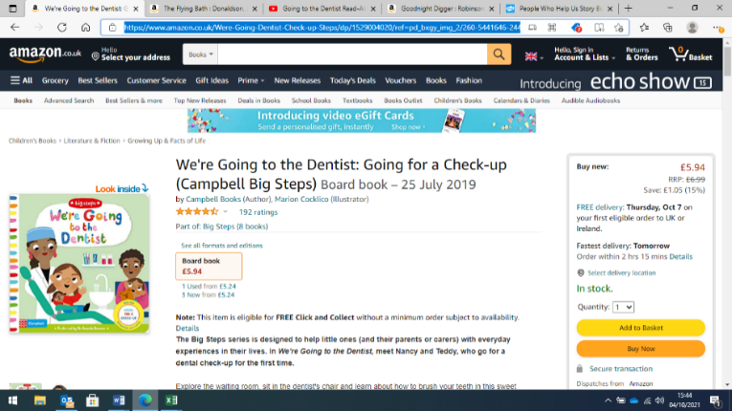  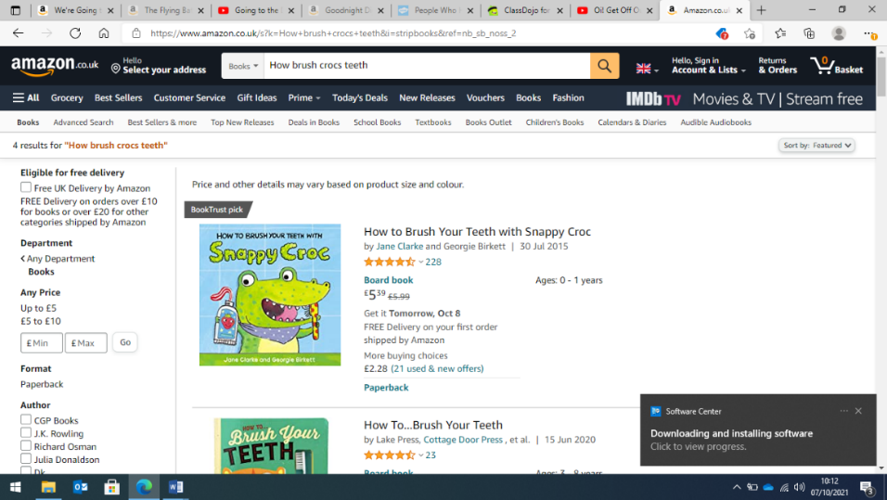  Mark making teeth | 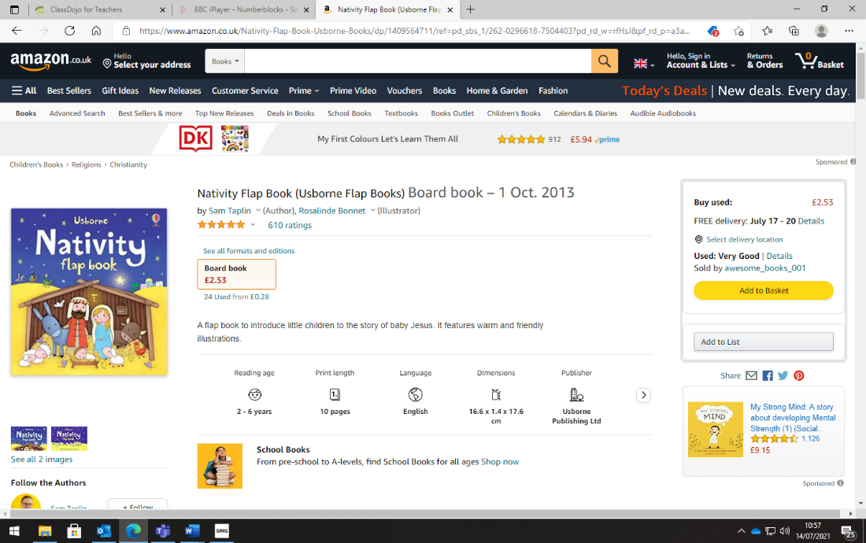  Creating Christmas cards |  |   Chalk sky pictures |  | 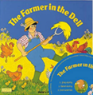  Gloop exploration |  | 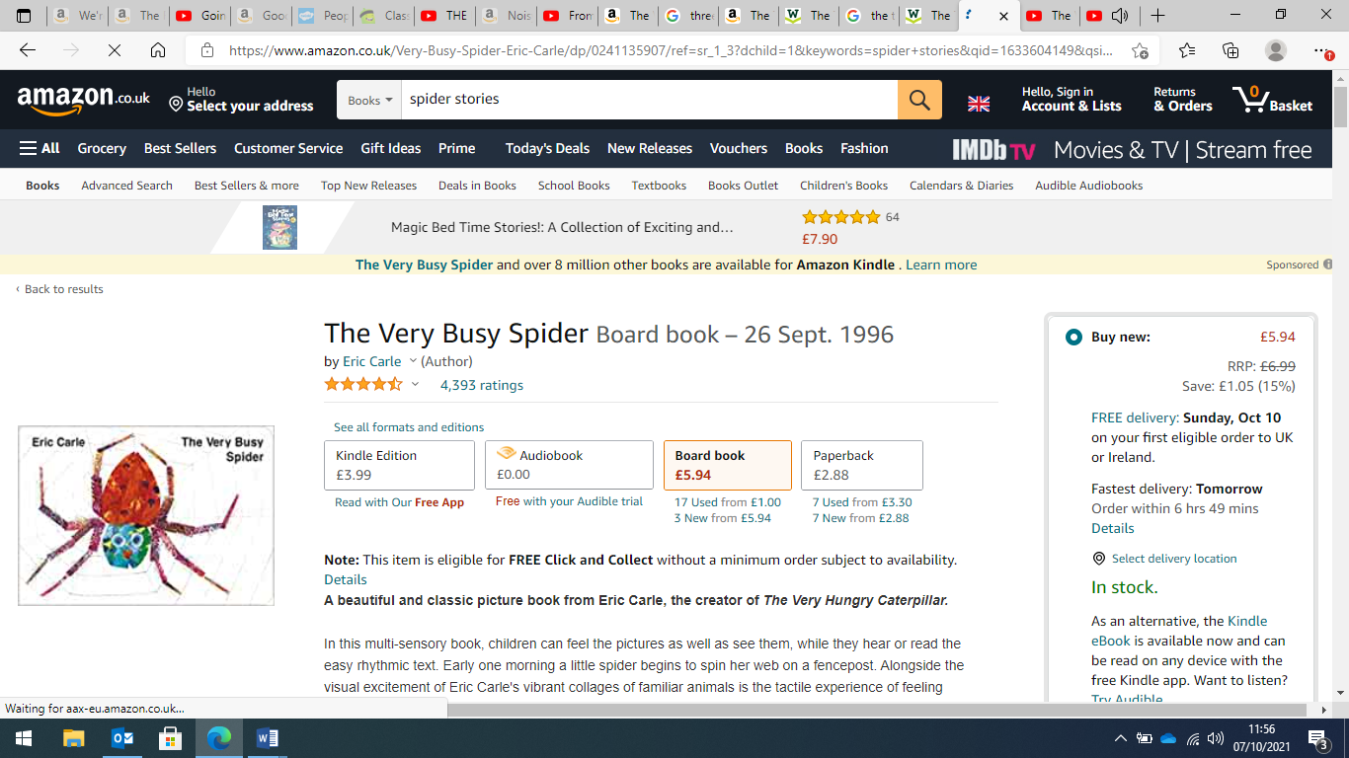  Creating spider webs |  | 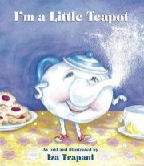  Tea pot decorating
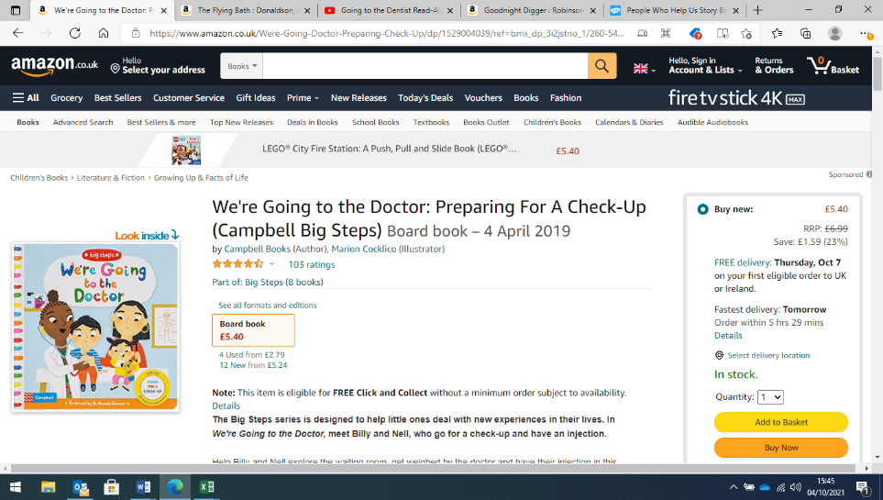  Fruit and vegetable printing | 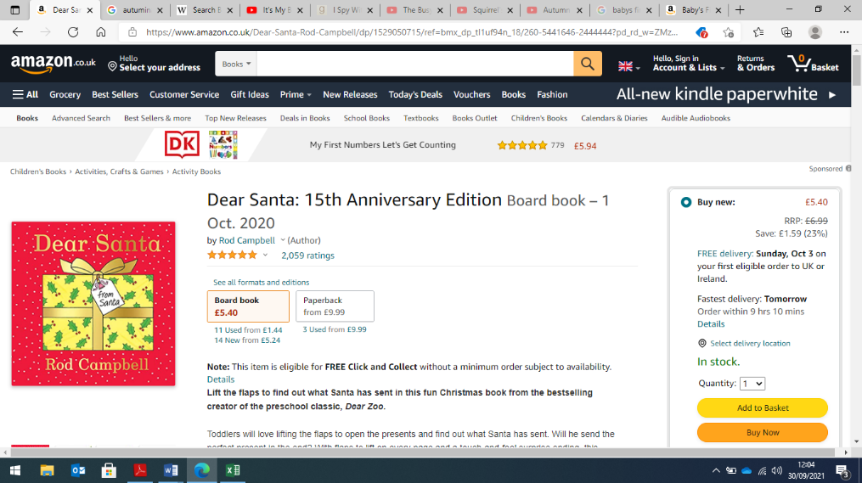  Mark making Christmas lists |  |  |  | 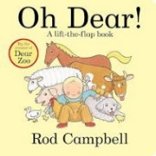  Animal paintings |  |  |  | 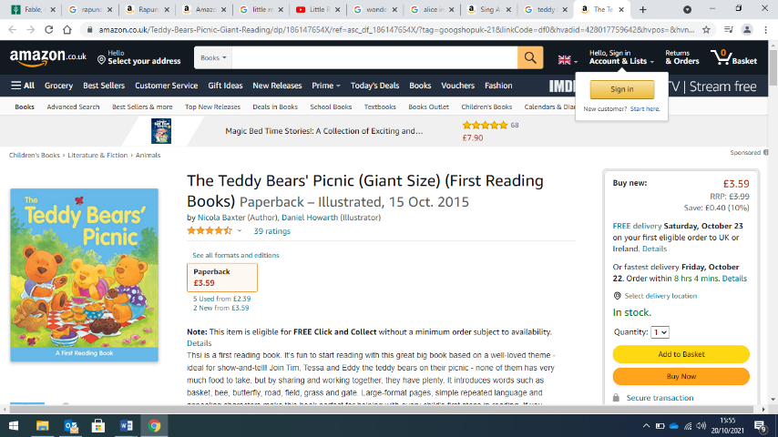  Mark making a picnic shopping list
Additional Storytime Reads
These stories are read to the children again and again, throughout the year. Through listening to repeated readings, and talking about what they have heard, the children have multiple exposures to vocabulary and the language of stories. Continued talk about words, as well as opportunities to use them, helps our children to become increasingly familiar with the language found within its pages. Through stories, our children encounter vocabulary that they may not hear in everyday conversation but will come across in writing, once they can read for themselves.
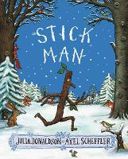 |  | 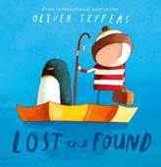 |  | 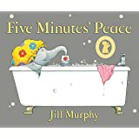 |  | 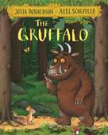 |  | 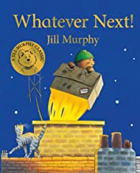
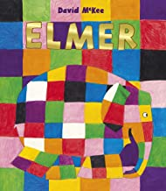 |  | 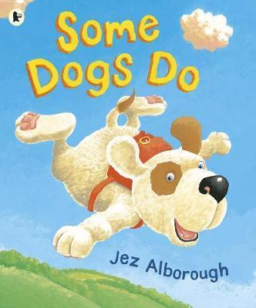 |  | 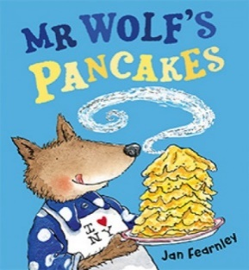 |  | 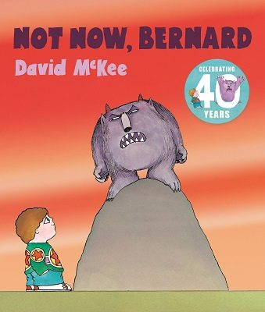 |  | 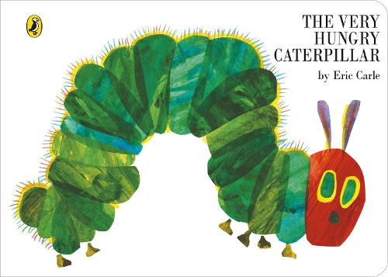
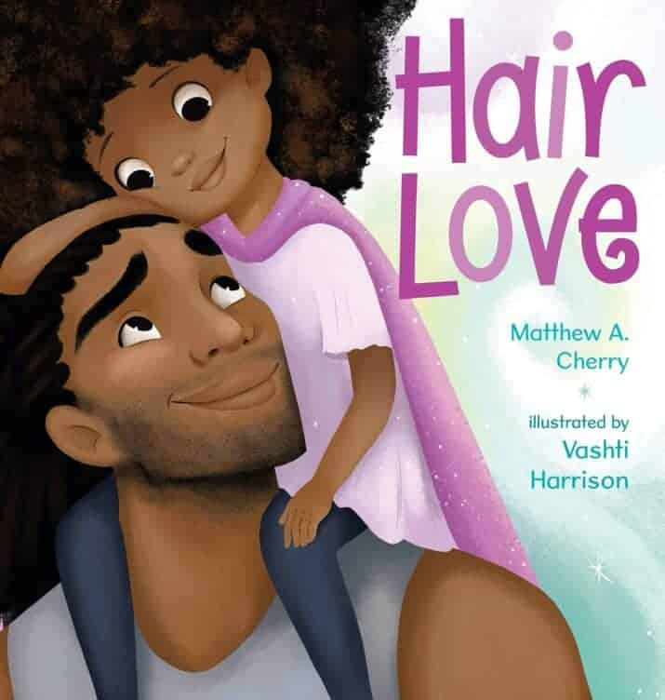 |  | 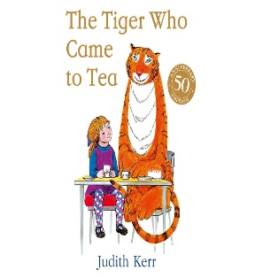 |  | 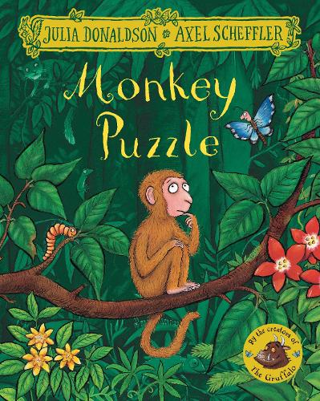 |  | 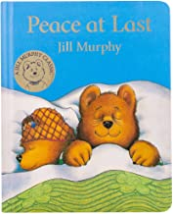 |  | 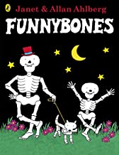
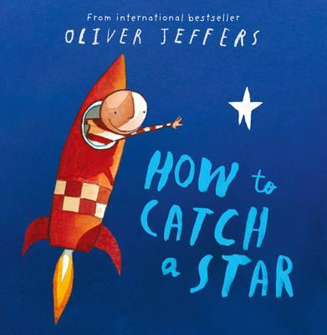 |  | 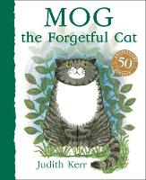 |  | 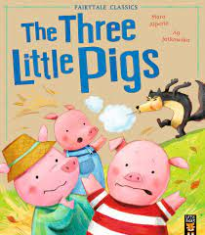 |  | 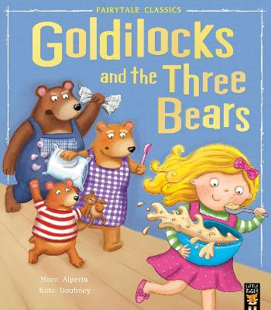 |  | 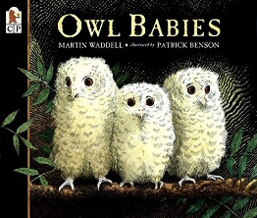
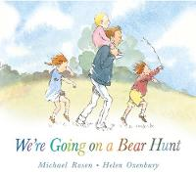 |  | 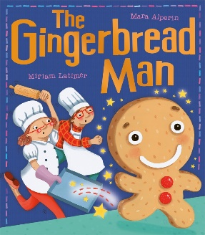 |  | 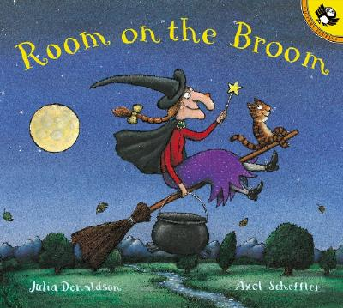 |  | 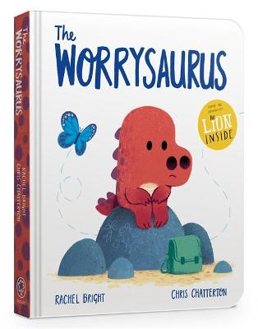 |  | 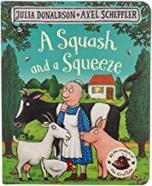
Daily Song, Rhyme and Poetry Time
Daily songs and nursery rhyme times are another important part of the day for our youngest children in school. Through enjoying rhymes, poems and songs, and reciting poems or parts of longer poems together as a class, we build our children’s strong emotional connection to language.
By learning poetry and songs using ‘call and response’, we enable our children to join in gradually. Each repetition strengthens their vocabulary, embedding new words.
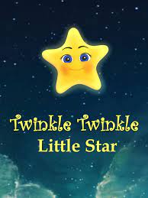
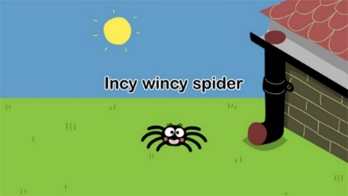

Hickory Dickory Dock  Row Row Row your boat.  Sleeping Bunnies  Wheels on the bus  Humpty Dumpty  Incy Wincy Spider  Baa baa black sheep | Twinkle Twinkle Little Star  I’m a little tea pot  Pat a cake pat a cake  Ring around the rosie  Old McDonald had a farm  If you’re happy and you know it.

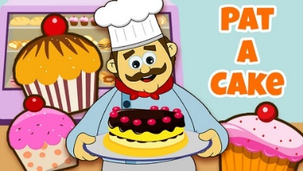
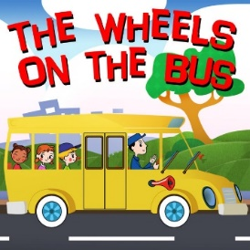
The Daily Poem
At Captain Webb Primary, we believe it is important to set aside 5 minutes every day to listen to and enjoy Poetry.
The Poetry Spine is a core of books that foster a love of poetry with the best children's anthologies, hand-picked by literacy expert Pie Corbett.

